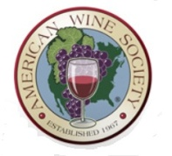
King George Chapter of the American Wine Society

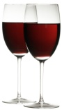
July, 2012

General Discussion:
Old News: None
New news:
- The subject of the By-Laws was brought to attention. They have never been formally documented and ratified.
- President motioned to accept the most recent documentation of the By-Laws. Motion was followed with a second from Mike Hyde and was accepted with a unanimous yay vote.
- The By-laws state that there is typically no meeting in July or August. It was concluded that if someone signs up for that month to present, then we will in fact hold a meeting. This will be re-written in to the next iteration of the By-Laws
- Paper products and who is responsible for them has been questioned. This will be discussed in the next Board meeting and will be documented in the next iteration of the By-Laws.
- Brad asked that anyone with suggestions/questions with regard to the By-laws should e-mail him.
Guests:
- Two Guests; Jane Marvin and Carolyn Ulfer

Presentation:
Malbec
Kathy and Chris Strickland gave a presentation on Malbec’s. We were treated with a starter wine; the Pigmentum Malbec Rose, 2010.
The presentation can be found on the web site under Tasting Notes.
Prices and favorite’s are below:

Favorites and prices of the presentation:

Wine | Malbec | Favorite Overall | Price | Purchased
#1 | 12 |  | $6.99 | Total Wine
#2 | 12 |  | $7.47
#3 | 4 |  | $11.99
#4 | 2 |  | $7.99
#5 | 9 |  | $6.99
#6 | 17 | 17 | $12.99
Rosé |  | 6 | $9.99

